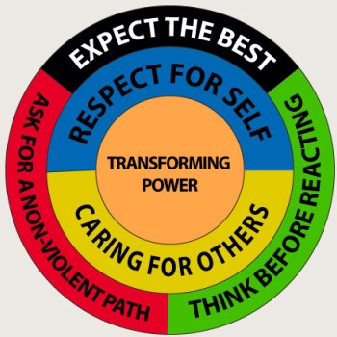 | Alternative to Violence – Palestine (AVP-P)  AVP registration license # 8632 in 2017 in Gaza city  Address: Apt # 12, 3rd floor, Al-Noor Building, Gaza city.  Tel: +972 (08) 2645935 and Mobile +972 (059)940 1667  Email: palestine@avp.intrernational  Website: www.avp.international/palestine

End Report on the 2 Basic Workshops along the Border During March of Return

Start date: May 8th 2018 and Ends at May 13th 2018
May 18th 2018
Background:
At least 100,000 of Palestinians living in the Gaza Strip marched "March of Return" to the blockaded border with Israel, set up camp, and peacefully expressed their desire to return to the homes from which they were expelled. With impunity, Israeli military forces used drones to drop tear gas over all the demonstrators and shot live ammunition at anyone they perceived to be coming "too close to the border". All those who were shot were men between the ages of 18 and 30.
A few hundred yards from Gaza's border with Israel, even as ambulances screamed past ferrying the injured and as tear gas canisters were dropped from drones, the atmosphere remained festive as families gathered for picnics. Shop owners set up stalls and sold ice cream, smoothies, nuts and sandwiches.
Today, more than 40 years later, the Gaza Strip has become an open-air prison and is on the brink of economic collapse. The Israeli siege has made the economic and humanitarian conditions completely unlivable in Gaza. Cut off from the rest of the world, in what continues to be one of the most densely populated places on earth, 97% of the water is deemed undrinkable and electricity is only available for 2-4 hours a day.
What has been Achieved?
The 2 basic workshops facilitated along the border during the current March of Return over the last 6 days were of great and tangible impressive results. A number of 30 youth from both sex was the total number of participants. The trainer Ms Miryam Abu Obadi who facilitated the last training has been selected to conduct this training. Participants introduced to the basic definitions of violence, Alternative to violence as a way of life for solving problems, transforming power and so on. Also participants introduced to Mandella theory and how to practice such power during the current March of Return.

Obstacles encountered during t the workshops
Generally speaking, the workshops have been smoothly facilitated through the organizing committee who are responsible for arrangement of community initiative. We (AVP-P) has been advised to coordinate with this committee to arrange for the workshops. However, some obstacles faced us like:
- Some miss coordination with the committee, they have little experience managing such initiatives;
- Hard to take some Photos to document the workshops activities;
- Number of injured cases close to the place of workshops;
- The environment during the workshops was scary however, the participants were very committed to attend the training.
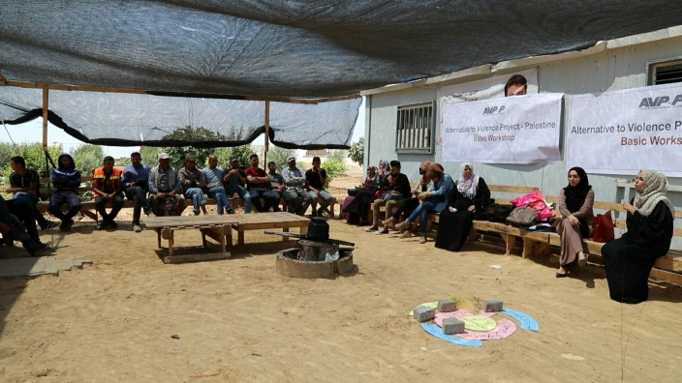 | 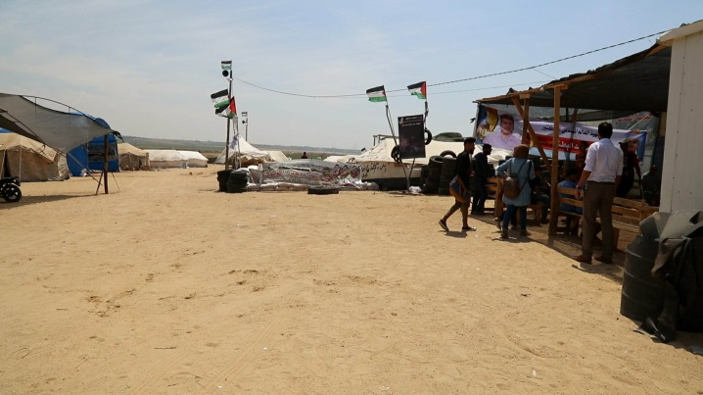
Trainees of AVP Basic workshop | Great March Return camp
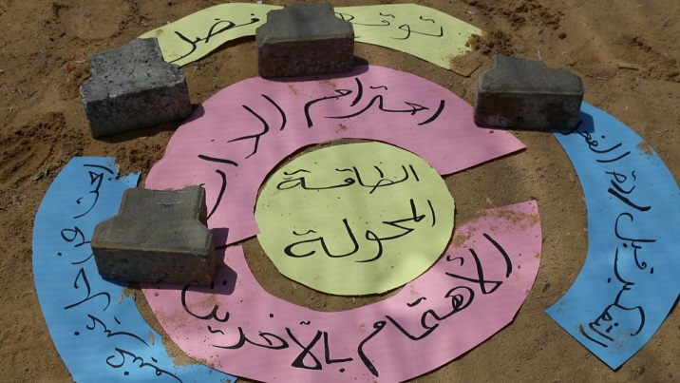 | 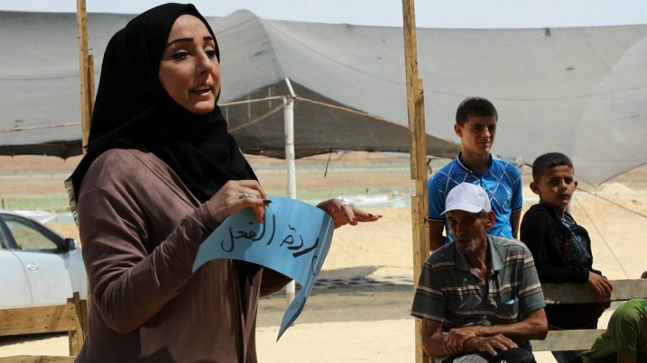
Mandela Circle | Trainer using Mandela circle
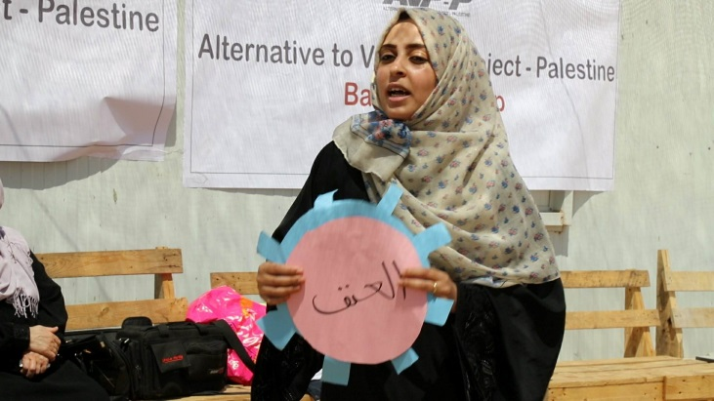 | 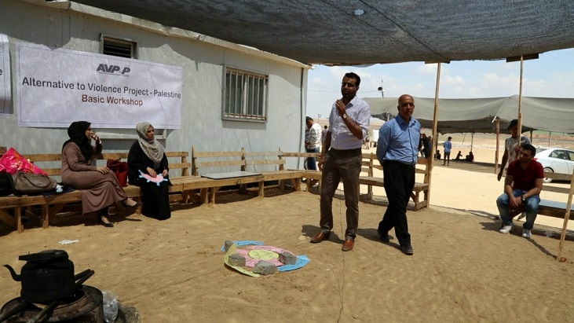
The trainer of the workshops | President of AVP-P speaks to the trainees
Joseph DiGarbo, AVP International coordinator  Email:jdigarbo@gmail.com  Lancaster, Pennsylvania  USA | Dr Mustafa El-Hawi AVP Palestine coordinator  Gaza city  Skype: mustafah22  melhawi@hotmail.com

