Israel-Palestine Working Group of NEYM Talking points

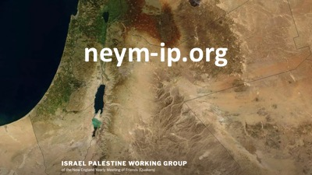

1. Our 2017 minute called for response with an implicit request for accountability. “That’s why I’m before you.”

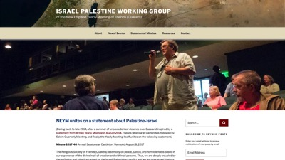

https://neym-ip.org/neym-statement-2017/

2. Israel-Palestine Working Group is reporting back on its April 14th Living Faith Panel & workshop.

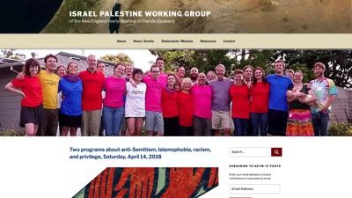

https://neym-ip.org/panel-discussion-about-anti-semitism-islamophobia-racism-and-privilege/

A. JOURNEYS TO ENGAGEMENT: a panel discussion “Living into NEYM’s Israel/Palestine Minute: Understanding the Interplay of Anti-Semitism, Islamophobia, and Racism.”

B. QUAKERS AND ANTI-SEMITISM: a workshop organized by Jonathan Vogel-Borne and Allan Kohrman

3. Burlington MM’s “Minute of Concern for Palestinians in Gaza” is an example of a time-sensitive crisis, which moved one meeting to respond.

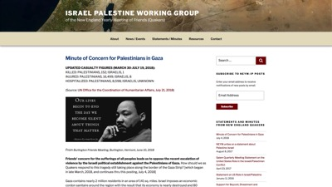

https://neym-ip.org/minute-of-concern-for-palestinians-in-gaza/

4. Invite Friends to visit/subscribe to neym-ip.org website & mention outdoor displays, lunch and dinner meetings, photo exhibit, website, and simple availability to talk personally with any of us at sessions.

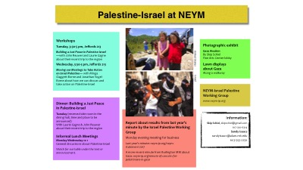

https://neym-ip.org/palestine-israel-programs-at-neym-sessions/

5. Reinforce AFSC’s major efforts:

A. No Way to Treat a Child—Emphasize parallel of Israel imprisoning 600 to 800 Palestinian children each year with U.S. government’s separation of refugee families at southern border.

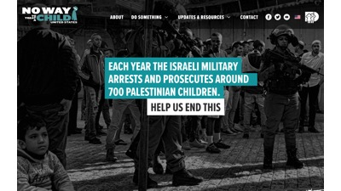

<https://nwttac.dci-palestine.org>

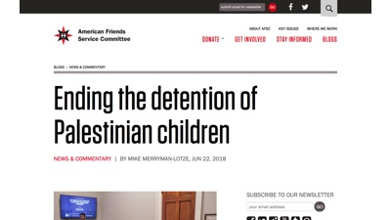

https://www.afsc.org/blogs/news-and-commentary/ending-detention-palestinian-children

B. End the blockade of Gaza:

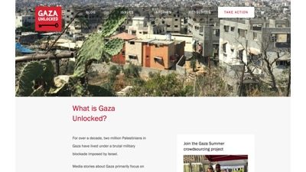

<http://www.gazaunlocked.org>

6. Introduce revised Minute of Concern for Palestinians in Gaza
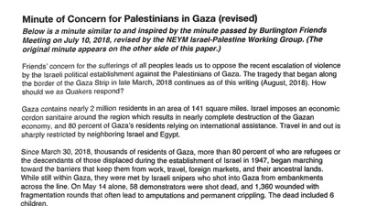

7. Ask will Sessions adopt this minute? Will NEYM ask monthly & quarterly meetings to consider?

Friends have throughout our history exercised persistent practices of speaking, listening, expectant waiting, community-building, and truth telling as ways to witness to the power of the Spirit.
—Diane Randall, Executive Director of Friends National Committee on Legislation (FCNL), gave Bible Half Hours at NEYM Sessions, 2018 (Hartford MM)

Go where are you least wanted, for there you are most needed.

—Abby Foster Kelly, early Quaker

